Name ________________________________________________ Date __________________ Period _____________
A Get-To-Know-Your-Lab-Equipment Activity
Objective: Be able to identify and describe the function of several laboratory supplies commonly used in Biology.
Directions: Fill in the chart with information regarding each piece of lab equipment. Answer the lab analysis questions at the end of the assignment.
Equipment Name and Picture | What is the function of this laboratory tool? | Other Information
Beaker  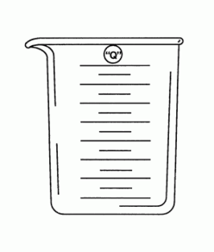 |  | A beaker is used to measure volume in what metric unit?  Accidents happen. What should a student do if the contents of a beaker spill?
Erlenmeyer Flask |  | How do you hold and move a flask if you are mixing chemicals?
Goggles |  | Accidents happen. What Should you do if something gets in your eyes during a lab?
Graduated Cylinder |  | A graduated cylinder is used to measure ___________ in mL.  This tool should only be read when it is placed on a flat surface. Why?
Pipet |  | A pipet is used when adding (choose one: small / large ) amounts of liquids.
Microscope Slide |  | Accidents happen. What should you do if you break a microscope slide?  What is the function of a compound light microscope?
Thermometer |  | A thermometer is used to measure temperature in what metric unit?  What is the freezing point of water?  What is boiling point of water?
Test Tube |  | When working with other materials, test tubes should rest in a __________________________.  What should you do with its contents if you are done using a test tube?
Petri Dish |  | When growing bacteria, you must first pour a gel substance called agar into the petri dish. Why do you think agar is necessary?
Ruler |  | A ruler is used to measure length in what metric unit?  A meter stick is _______ cm long.

Analysis Questions:
- Which lab equipment tool would you use to measure exactly 4 mL of water. Explain your reasoning.

- Which lab equipment tool would you use to heat a small amount of liquid over a Bunsen burner? Explain.
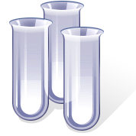
- Which lab equipment tool would you use to measure approximately 50 mL of salt water? Explain.

- Which lab equipment tool would you use to drop small quantities of isopropyl alcohol into a test tube? Explain.

- Which lab equipment tool would you use to determine if water is almost to its boiling point? Explain.

