Name _______________________________________________ Date _______________________ Class ___________
Genetics Unit Test Review
- What role does DNA play in the transmission of genetic information?
DNA stores genetic information and contains the instructions for building proteins.
- What roles does RNA play in the transmission of genetic information?
RNA carries the genetic message from the nucleus and is used for building proteins.
- Compare and contrast the structures of DNA and RNA. You must list at least 3 factors for each and 2 factors shared.
DNA
Genetic molecule
Used for building proteins
Single Stranded
Ribose Sugar
Uracil
Can leave nucleus
Double Stranded
Deoxyribose Sugar
Thymine
“Stuck” in nucleus
RNA

- Describe the semiconservative model of DNA replication
The original strand of the DNA molecule is used as a template for the new strand. Following replication, each molecule of DNA is half original, half newly constructed.
- Describe the overall purpose and process of DNA replication. Where in the cell does this take place?
The purpose of replication is to make more, identical copies of DNA. This takes place in the nucleus. DNA Helicase (enzyme) unwinds and unzips DNA and then DNA Polymerase (enzyme) puts together the new, complementary nucleotides.
- Determine the complementary DNA sequence following DNA replication: A T G C G A T C G A A G
T A C G T A G C T T C
- Describe the overall purpose and process of transcription. Where in the cell does this take place?
The purpose of transcription is to create a molecule of messenger RNA (mRNA) using a molecule of DNA so that the DNA “instructions” can leave the nucleus. This process takes place in the nucleus. DNA Helicase (enzyme) unwinds and unzips DNA, RNA Polymerase (enzyme) puts together the complementary RNA molecules, building a single stranded molecule of RNA that can leave the nucleus.
- Determine the complementary mRNA sequence following transcription: A T G C G A T C G A A G
U A C G U A G C U U C
- Describe the overall purpose and process of translation. Where in the cell does this take place?
The purpose of translation is to build a protein molecule at the ribosome by “reading” the mRNA codons and bringing the proper/signaled amino acids. This takes place at the ribosome.

- Use the coding chart to determine the amino acid sequence for the mRNA codons: A G C U U C G A A
Ser – Phe - Glu
- In terms of meiosis, how are traits passed down from parents to offspring?
Alleles separate during the process of meiosis and gametes (sex cells) are produced. Sex cells combine during fertilization and the alleles of the parents are passed on to future generations.
- Mendel made two very important conclusions following his work with pea plants. Define both.

Law of Segregation  Alleles for the same gene separate during the creation of gametes during the process of meiosis. | Law of Independent Assortment  Alleles/genes are independent of one another, which allows us to study more than one trait at a time (dihybrid cross)

- Dominant Trait
- Recessive Trait
- Genotype
- Phenotype
- Gene
- Allele
- Match the term with the correct definition.
__E____ Portion of DNA which codes for a protein, which leads to a trait.
___F___ The different forms of a gene, represented by letters.
____A__ The trait which appears in the F1 hybrid generation.
___B___ The trait which is “hidden” in the F1 generation.
____C__ The genetic makeup of an organism (BB, Pp, ff)
____D__ The physical expression of alleles (Brown hair, blue eyes).
- For each genotype, indicate whether it is heterozygous (HE) or homozygous (HO)
AA ___HO______ Bb _____HE____ cc ___HO______ DD _____HO____ Ee _____HE____
- What is a mutation?
A permanent change in a cell’s DNA
- A mutation in which type of cell can be passed along from parent to child?
- Compare and contrast sexual and asexual reproductive outcomes. You must list three differences for each and two similarities
Asexual
Sexual

- Which cell division process is used to produce diploid somatic cells? mitosis
- Which cell division process is used to produce haploid gametes? meiosis
- Mitosis or Meiosis? Asexual cell reproduction, cell divides once, produces somatic cells, two daughter cells are genetically identical to the parent cell. Mitosis
- Mitosis or Meiosis? Necessary for sexual reproduction, cell divides twice, produces gametes, crossing over of chromosomes, four genetically different daughter cells. Meiosis
- True or False: Crossing over, the way chromosomes align during metaphase, and the combination of egg and sperm all lead to genetic variation within a species. True
- Meiosis is necessary for asexual reproduction, sexual reproduction, or both? Sexual reproduction
- Mitosis or Meiosis? Takes place all over the body. Mitosis
- If a parent cell has 80 chromosomes, how many chromosomes will the daughter cells have following MITOSIS? 80
- If a parent cell has 80 chromosomes, how many chromosomes will the daughter cells have following MEIOSIS? 40
- In Mitosis, DNA is duplicated ___once____ and the cell divides __once____, producing ___2__ diploid daughter cells.
- In Meiosis, DNA is duplicated ____once___ and the cell divides ___twice____, producing ___4_ haploid daughter cells

- Punnett Square Practice
- In daises, yellow flower color is dominant to white flower color. Give the phenotypes for the following genotypes.
Y Y ____yellow_____________ Y y ____yellow__________ y y _______white_______________
- In guinea pigs, short fur is dominant and long fur is recessive. Give the possible genotype(s) for each phenotype.

Short fur ______________________ Long Fur ______________________

- In mice, black eyes are dominant to red eye color. Complete a punnett square which shows the cross between a homozygous black eyed mouse and a red eyed mouse. Give the probabilities for each genotype and phenotype.

- Using the information from “C,” complete a punnett square which shows the cross between two heterozygous black eyed mice. What is the likelihood that the offspring from this cross will have red eyes?

- In roses, red flower color is incompletely dominant with white flower color. The heterozygous condition results in pink flowers. This is an example of ___________incomplete dominance_______.

Show a cross between two pink-flowered plants. Give the probabilities of each genotype and phenotype.

- In certain fish, red and blue fish when mated create offspring with a patchwork of blue AND red scales. This is an example of _______codominance________________ inheritance.

Show a cross between a blue fish and a fish with patchwork red/blue scales. Give the probabilities of each genotype and phenotype

Pedigree Practice
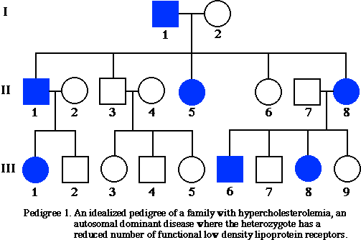

a. What is the relationship between III – 6 and III – 7?
brothers
b. The pedigree above traces the Widow’s Peak hairline within a family. According to this pedigree, is the presence of a Widow’s Peak dominant or recessive? How do you know?
dominant, doesn’t skip generations
c. Identify the genotypes of as many members of this pedigree as you can. Label them on the pedigree.
d. Couple II-1 and II-2 are planning on having another child. What is the likelihood that this child will have a Widow’s Peak? Show your punnett square.

Karyotype
a. What is a Karyotype?
b. The first 22 pairs of chromosomes are known as ___autosomal____________ chromosomes, while the 23 pair are the ___sex__________ chromosomes.
c. The karyotype below shows the chromosomes of a MALE. How do you know this?
d. The karyotype below is of someone with the genetic disorder known as Edward Syndrome, or Trisomy 18.
How can you tell this by looking at a “map” of the person’s chromosomes?

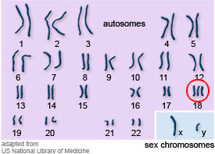

Match the vocab term to its proper definition.

- Gel Electrophoresis
- PCR
- Cloning
- Biotechnology
- Genetic Engineering
1. The creation of an organism that is genetically identical to another.
Used by scientists to create “Dolly” the sheep. ____C____
2. Also known as “Transgenic Manipulation.” This process is the direction
manipulation of an organism’s genome. Allows scientists to insert the
DNA of one organism into a completely different species ___E_____
3. The process which takes a small fragment of DNA and copies it millions
of times through repeated heating and cooling. Used by scientists to
diagnose diseases and identify criminals. ___B_____

4. A process which allows scientists to sort segments of DNA by length
using electrical currents. Used for “DNA Fingerprinting” in the solving of
crimes and identification of family relationships. ______A__

5. The use of living organisms to develop or make useful products.
Scientists use these processes in various fields including food
production, agriculture and medicine. ____D____
Gel Electrophoresis
Cloning
PCR
Genetic Engineering

Photosynthesis/Respiration/ATP
What is ATP? Adenosine Tri Phosphate- energy molecules of the cell

How is energy stored and released? Energy is stored in the phosphate bonds, when the bond is broken energy is released.

What is the equation for photosynthesis? Which organelle does it occur in? Photosynthesis takes place in the chloroplast
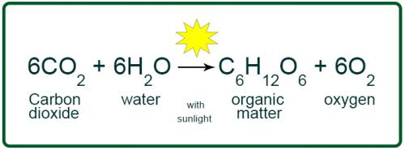

What is the equation for respiration? Which organelle does it occur in? Cellular Respiration occur in the mitochondria

