EOC Organisms Review - KEY

1. Characteristics of living things…
   1. All living things are made up of __________***cells***_______________.
   2. All living things ______***grow***__________ and develop.
   3. All living things have the ability to _________***reproduce***________________.
   4. All living things maintain ___________***homeostasis***________________, a stable internal environment.
   5. All living things require the use of _______***energy***_________________.
   6. All living things _______***respond/adapt***________________ to their environment.
2. Be able to classify organisms into their kingdoms, based on their characteristics.

|  |  |  |  |  |  |  |
| --- | --- | --- | --- | --- | --- | --- |
|  | **Archaebacteria** | **Eubacteria** | **Protista** | **Fungi** | **Plantae** | **Animalia** |
| **Cell Type**  **(Pro/Eu)** | ***Pro*** | ***Pro*** | ***Eu*** | ***Eu*** | ***Eu*** | ***Eu*** |
| **Cell #**  **(Uni/Multi)** | ***Uni*** | ***Uni*** | ***Both*** | ***Both*** | ***Multi*** | ***Multi*** |
| **Reproduction Type** | ***Both*** | ***Both*** | ***Both*** | ***Both*** | ***Both*** | ***Sexual*** |
| **Nutrition (Auto/Hetero)** | ***Both*** | ***Both*** | ***Both*** | ***Hetero*** | ***Auto*** | ***Hetero*** |
| **Examples** | ***Bacteria in hot springs*** | ***Strep throat bacteria*** | ***Amoeba, Algae, Paramecium*** | ***Mushrooms*** | ***Oak Trees*** | ***Dog*** |

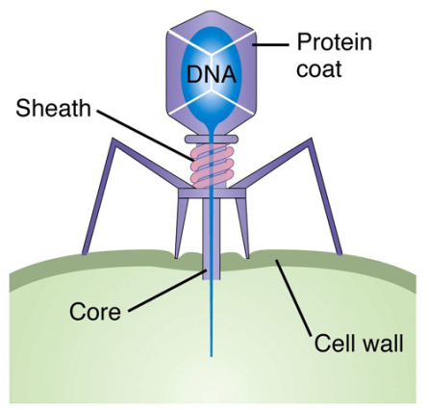

1. Why are viruses considered nonliving? What are the major parts of a virus?  
   ***They are not capable of reproducing on their own (require a host cell)   
   DNA and protein coat are the major parts of a virus***

1. Write the scientific name of the elephant in its correct binomial nomenclature.

**[ ELEPHAS MAXIMUS ]  
  
*Elephas maximus or* Elephas maximus**

1. How do organisms obtain the energy needed to sustain life?
   1. Autotroph Definition:  
      ***Capable of producing their own food through the process of photosynthesis***

***\*\*\*Heads up!\*\*\****

**Are fungi autotrophic or heterotrophic???**

* 1. Heterotroph Definition:  
     ***Must consume other organisms for nutrients***

1. Compare and contrast asexual and sexual reproduction.

**Sexual Reproduction**

**Asexual Reproduction**

***two parents***

***Genetically different offspring***

***Low # of offspring***

***One parent***

***Genetically Identical offspring***

***High # of offspring***

***Produces offspring***

1. Know the overall purpose and process of photosynthesis and cellular respiration.

|  |  |
| --- | --- |
| **Photosynthesis** | **Cellular Respiration** |
| * Takes place in the ___***chloroplast***________ * Converts ____***energy***____ from the ___***sun***__ into ______***food***_____ for the plant. * Takes in: ***Light energy, carbon dioxide, water*** * Releases: ***Glucose and oxygen*** | * Takes place in the _____***mitochondria***_______ * Breaks down ____***food (glucose***)____ in order to produce energy in the form of (_***ATP***_) * Takes in: ***Glucose and oxygen*** * Releases: ***energy (ATP), carbon dioxide, water*** |

1. Compare and contrast aerobic and anaerobic respiration. How does the energy produced in each compare?  
   a. Aerobic respiration requires the use of ***oxygen*** and releases a ***large*** amount of energy.

b. Anaerobic respiration occurs ***without oxygen*** It releases a ***small*** amount of energy and produces ***lactic acid*** which causes the burning in your muscles.

1. What are the levels of classification from largest to smallest (most specific)?

***Domain***

***Kingdom***

***Phylum***

***Class***

***Order***

***Family***

***Genus***

***species***

***Did***

***King***

***Phillip***

***Come***

***Over***

***For***

***Great***

***Spaghetti***

1. Which term describes an organisms ability to maintain a stable internal environment?
   1. Regulation
   2. ***Homeostasis***
   3. Respiration
   4. Metabolism
2. Unlike plant cells, animal cells do NOT have any
   1. Mitochondria
   2. Cell membranes
   3. Ribosomes
   4. ***Cell walls***
3. Which situation is NOT an example of an organism’s ability to maintain dynamic equilibrium?
   1. Guard cells aid in the regulation of water content in a geranium plant.
   2. ***Water passes into an animal cell, causing it to swell and burst.***
   3. Insulin lowers the blood-sugar level in a human after eating a big meal.
   4. A runner perspires while running a race on a hot summer day.

C:\Users\kmd13298\AppData\Local\Microsoft\Windows\Temporary Internet Files\Content.IE5\USN4D55T\MC900030486[1].wmf

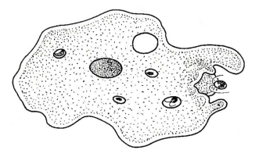

Single-celled Organism A Multicellular Organism B

1. Which statement concerning organism A and organism B is correct?
   1. A contains tissues, whereas B lack tissues
   2. A and B are made up of the same organs
   3. ***A and B both have structures which maintain homeostasis***
   4. A reproduces sexually, B reproduces asexually
2. Which end product of respiration is the greatest benefit to an organism?
   1. Glucose
   2. Carbon dioxide
   3. ***ATP molecules***
   4. Water molecules
3. What type of energy conversion occurs during the process of photosynthesis?
   1. Light energy into heat energy
   2. Chemical energy into light energy
   3. ***Light energy into chemical energy***
   4. ***Light energy into chemical energy***
4. Which process provides most of the oxygen found in the Earth’s atmosphere?
   1. ***Photosynthesis***
   2. Aerobic respiration
   3. Anaerobic respiration
   4. Phosphorylation
5. Which word equation represents the process of cellular respiration?
   1. Carbon dioxide + glucose 🡪 water + oxygen + energy
   2. Glucose 🡪 alcohol + carbon dioxide
   3. Light energy + carbon dioxide + water 🡪 glucose + oxygen
   4. ***Glucose + oxygen 🡪 carbon dioxide + water + energy***