EOC Evolution Review - Key
- The slow, gradual change in a species is called _____evolution_____________.
- Define the following terms and give an example of each
  - Homologous Structure – Similar anatomical structures (human arm, dolphin flipper), different function.

  - Analogous Structure – Similar function, different anatomical structures (bird wing, butterfly wing)

  - Vestigial Structure – Structure that no longer serves a purpose (hip bones on whale)

- What is natural selection? Who proposed the Theory of Evolution through natural selection?
Natural selection is the process through which organisms best adapted to their environment survive and reproduce, passing on their beneficial adaptations to future generations. Charles Darwin.

- Give an example of natural selection
Insects becoming resistant to pesticides over many generations.
- What is “survival of the fittest”?
Organisms best adapted to their environment are more likely to survive and reproduce.
- Explain how natural selection, adaptation, and fitness are related to one another.
More “fit” (well adapted) organisms are more likely to be “selected” by nature, meaning they will survive and reproduce.
- What is convergent evolution? Give an example.
Evolution through which organisms become more similar. Marsupials in different parts of the world evolving similar traits.
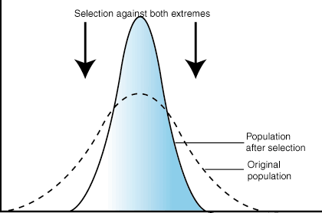
- What is divergent evolution? Give an example.
Evolution through which organisms become more different. The finches of the Galapagos Islands.
- What is stabilizing selection? Draw a graph and give an example.

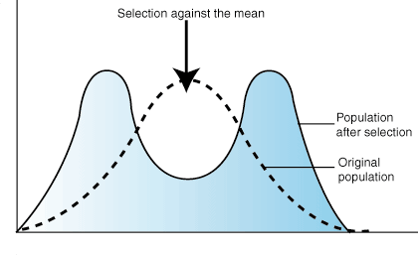
Selection against both extremes and towards the median. Example: human birth weight.
- What is disruptive selection? Draw a graph and give an example.
Selection against the mean and towards both extremes. Example: snake color
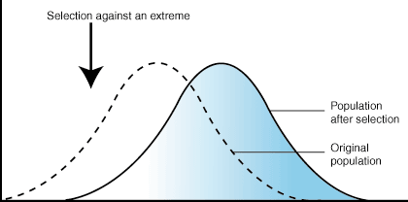
- What is directional selection? Draw a graph and give an example.
Selection against one extreme and towards another.

- What is speciation? List two ways that speciation can occur.
Speciation is the process of evolution which results in the new species. Speciation occurs as a result of geographic isolation and genetic drift.
- What is a mutation? How does it contribute to adaptation?
Any change in a genetic sequence. Natural selection acts upon traits controlled by genes, so new traits can appear as a result of mutations.
- What was the first type of cell on Earth?___prokaryotic bacteria cell_____________
- Define the following terms:
  - Mimicry – when one species develops adaptations similar to another

  - Camouflage – adaptations that allow an organism to blend in with its environment

- List and define the three factors that influence natural selection
  - ___overproduction___: more offspring are produced than can possibly survive

  - ___competition___: organisms trying to utilize the same resources

  - ___variation___: genetic differences between organisms of the same species

- Describe how antibiotic resistance occurs
Antibiotics are taken to kill bacteria. Some bacteria have natural, genetic immunities to the antibiotics. Those bacteria survive and reproduce, creating a future generation of bacteria that is entirely resistant to the antibiotic.

- Define the following terms:
  - Relative Dating – “dating” of fossils using the sediment layer. Oldest at bottom.

  - Absolute (Radiometric Dating – exact dating of fossils using process such as carbon dating

- What are the two factors that determine whether organisms are a separate species or not?
Whether or not they can produce fertile offspring, whether or not they can reproduce in their natural habitat

- This diagram shows what rate of speciation? Define it.
Punctuated equilibrium – long periods of no change followed by short, rapid bursts of change

- This diagram shows what rate of speciation? Define it.
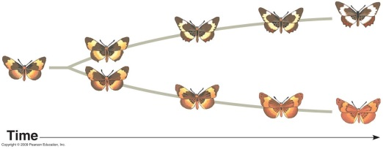
Gradualism – long periods of slow, gradual change, leading to the development of new species

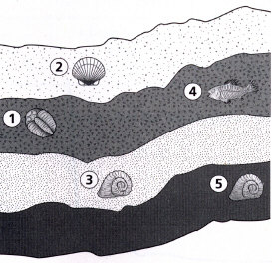
- Put the fossils in order from oldest to youngest based on the diagram below.
5 (Oldest) – 3 – 1 – 4 – 2 (youngest)

Please answer the following questions using the choices provided. Choices may be used more than once.
- Homologous Structure
- Analogous Structure
- Vestigial Structure
- Molecular/Biochemical Evidence
- Fossil Evidence
- Embryological Evidence

- A modified structure seen among different groups of descendants._________A________
- In the earliest stages of development, a tail and gill slits can be seen rabbits, fish, birds, and humans.____F___
- Exemplified by forelimbs of bats, penguins, lizards, and monkeys.______A________
- The forelimbs of flightless birds._____C________
- DNA and RNA comparisons may lead to evolutionary trees or cladograms._______D_________
- Bird and butterfly wings have the function but different structure._______B___________
- A body structure no longer used but may have had a function in an early ancestor._________C__________
- Structure associated with divergent evolution._____A_________
- Structure associated with convergent evolution.______B_________
Use the following diagram to answer questions 32-38
reptiles
amphibians
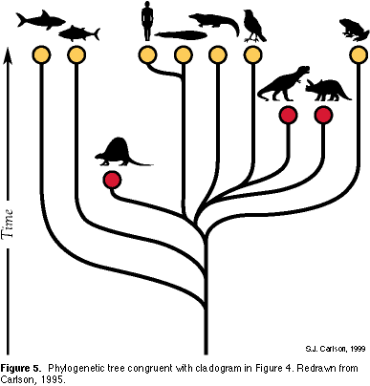
dimetrodon
T-Rex
whale
fish
shark
Y
- The above diagram is called a _______cladogram___________________________________________
- In the diagram above, the Y axis represent what?________Time____________________________
- Where would NOW be located on this diagram?_______Top______________________________
- If a line stops before the top, what does this mean?
Species has become extinct
- According to the diagram, humans share a most recent common ancestor with which animal?
Whale
- Which is the first animal to go extinct?____Dimetrodon__________________________________________
- What living animals is the T-rex MOST closely related to?_________Bird_______________________

