Biology Syllabus
South Cobb High School Fall 2016

Instructors: Mrs. Iesha Harrison and Mrs. Neshala Liggins
Phone: 770-819-2611 ex.1804
Email: iesha.harrison@cobbk12.org
neshala.liggins@cobbk12.org
School Address: 1920 Clay Rd. Austell, GA 30106
Room: FTA Building 804
Class Blog: http://harrisonsouthcobbscience.weebly.com/
Tutoring: Thursday, All other days and times are by appointment only.

Biology is the study of life. The specific areas covered are: Biochemistry, cells, genetics, classification, evolution, and ecology. This course is required for graduation and will introduce the students to the various biological functions and processes in addition to the Nature of Science.
The goal of this syllabus is to give the student a summary of the purpose, topics, grading procedure, time line, and class expectations for this class. The purpose of this class is to give students an overview of biology so the student may be better prepared to master the biology standards as set by the Georgia Department of Education in preparation for the class End of Course Assessment(EOC).
The students’ grade will be determined by an evaluation of the level the student has mastered each standard and an EOC at the end of the semester. Mastery of the standards will be achieved by the student s’ performance on quizzes, laboratory assignments, individual, group and class activities.
Grade Breakdown | Percentage of Grade
EOC | 20%
Unit Tests | 30%
Projects | 15%
Notebooks/Labs | 15%
Mini Quizzes | 10%
Daily Assignments | 10%
COBB COUNTY grade scale:
90-100 = A
80-89 = B
74-79 = C
70-73 = D
Below 70 = F

Classroom Rules:
- Follow directions the first time they are given.
- Class time is for class activities.
- Food, candy or drinks should not be consumed in class.
- Use respectful language at all times.
- Raise your hand to ask questions and/or make a comment

Rewards for choosing to follow rules
“Shout out” from teacher
Ticket
Positive phone call home
Smile from teacher
The joy of learning and success!
Discipline Procedures:
1st Offense- Warning
2nd Offense- Student conference and parental contact
3rd Offense- Detention
4th Offense- Administrative referral

Materials Needed
- 3 Subject Spiral Notebook
- Internet access (see Media Center hours)
- Pens/Pencils
- Glue Sticks
- Color pencils (optional, but encouraged)
- Highlighters (optional, but encouraged)

Beginning of class
At the beginning of every class, you will be given a warm-up activity which will be counted for part of your grade. When you enter class, you should begin this every day. Daily Starters will be taken up every other Friday for a grade.

Hall Passes
BATHROOM NEEDS SHOULD BE ADDRESSED PRIOR TO ARRIVING IN CLASS! Each student must sign out (date, signature, and time out) and sign in from restroom and water breaks. NOTE: No passes will be given in the first and last 15 minutes of class and during direct instruction.

Testing:
You will be given at least 2 days’ notice prior to a test. Generally the day before a test no new material is covered. If you are absent the day before the test and no new material has been covered, you will be expected to take the test the day you return. Certain conditions must be maintained while evaluations are taking place. If you break any of the rules presented here for these conditions, then your grade may reflect this with a forfeiture of points.

All students must adhere to the following rules during testing until every student has completed the test or quiz:
- Stay silent
- Stay seated
- Keep all your materials in your possession (No sharing)
- Keep eyes on your own work (No cheating)
- Keep your answers covered while testing

Laboratory Time:
Each student will be expected to work with a partner (or partners) and participate in lab activities. Labs will be done in class and all safety rules must be followed. Failure to do so will result in lack of participation for the lab and a grade of zero will be assigned. If a lab activity is missed for any reason, it is the responsibility of the student to schedule a make-up lab immediately upon your return to school. If the student cannot make up the lab the student may be given an alternate assignment.
There is to be no horseplay in lab EVER! The instructor reserves the right to remove any student that is a safety hazard from the lab. If a student is removed from the lab, the student will receive a zero for the lab day. No student may participate in lab without passing the safety quiz and turning in a safety contract signed by the student and their parent or guardian. If a student is not allowed to participate in a lab for this reason, he/she will receive a zero for that lab.
Electronic Devices
Electronic devices and accessories should be kept silent and out of sight unless specified by the teacher for a science lesson.

Tardiness to Class:
If you are not in the classroom when the final bell rings, you will be marked tardy. Students will be referred to an administrator after THREE unexcused class tardies. See handbook for the appropriate consequences, which may include administrative detention, Friday Extended Day, ISS, OSS and loss of privileges.

ATTENDANCE AND MAKE-UP POLICY:
A student who is present and actively participates is more likely to be successful; however, if a student is absent, he/she has one day for each day of excused absence to make up the work. (For example, a student absent 2 days would have 2 days to make-up the work.) Students are responsible for asking their teachers for the make-up work. A student with an unexcused absence may ask for assignments and may choose to complete them in order to keep up with the class; however, the teacher is under no obligation to grade the work. Students should always check the blog the day they are absent. If you are absent on the day prior to the test (also known as the “review day”) you will be required to take the test on the regularly scheduled day.

“FLIPPED” CLASSROOM DESCRIPTION:
This class will utilize the flipped classroom many times throughout the semester. The flipped classroom is a pedagogical model in which the typical lecture and homework elements of a course are reversed. Short video lectures are viewed by the students at home prior to the class session, while in-class time is devoted to exercises, projects, and discussions. By flipping the on-level Biology course we are better able to encourage active learning, student engagement, and knowledge application. The video portion of the course is extremely critical to the flipped approach; students will therefore need to be proactive regarding watching the videos on their own time, whether it is through internet access at home or at school. Media center hours are 7:30am-4pm Monday through Thursday and 7:30am-3:30pm on Fridays.

ACADEMIC INTEGRITY:
Cheating is considered a serious matter. The parents of a student who has been involved in cheating will be notified and the student will receive a grade of zero for the test or evaluation period, and a grade of U in conduct.

For the Science Department, cheating is defined as, but is not limited to, the following acts:

- Copying anyone’s answers to questions, lab activities, study guides, classwork or homework assignments (this also applies to other teachers reporting copying being done in their classrooms on similar assignments).
- Looking onto another student’s paper or any resources during a test or quiz.
- Having available any study notes or other test aids during a test or quiz without the teacher's permission.
- Collaborating on assignments when independent work is expected. Be certain that individual lab reports, even when performed as a group, are written in your own words.
- Taking any information verbatim from any source, including the Internet, without giving proper credit to the author, or rearranging the order of words and/or changing some words as written by the author and claiming the work as his or her own, i.e., plagiarism.
- Using external resources such as web sites or apps to complete an assignment or assessment unless specifically permitted by the teacher.
- Taking pictures of assignments or assessments without the consent of the teacher.
- Students displaying or using cell phones or any other technology devices during tests and/or quizzes will be referred to administration, and will be given a zero for that test or quiz with NO opportunity to make up those points

Recovery:
Opportunities designed to allow students to recover from a low or failing cumulative grade will be allowed when all work required to date has been completed and the student has demonstrated a legitimate effort to meet all course requirements including attendance. Teachers are expected to establish a reasonable time period for recovery work to be completed during the semester. All recovery work must be directly related to GPS standards and must be completed prior to the EOC.

Bio Tickets:
Bio Tickets will be awarded at the teacher’s discretion to those who exceed expectations-academically and behaviorally. Every Friday the teacher will have a drawing for a gift bag at the end of class where you could receive supplies, bonus points, and other rewards.

Remember the Five Keys to Success:
- Be present and on time EVERYDAY!
- Come to class prepared with a mind ready to learn.
- Be respectful to others their property and the learning process
- Follow directions the first time.
- Strive to do your best.

Student/Parental Homework

I will be using an anonymous reminder website as a classroom tool (called Remind.com). This website allows me to send text messages to students and parents about upcoming assignments, quizzes, or tests. It also allows me to notify students of any changes that might occur before the next day’s class. This is an anonymous system, so I do not have access to you or your child’s cell phone number and vice versa. Your students will enroll through this program during class, but I would like for YOU (parents/guardians) to enroll your cell phone number (or email if you prefer) as well! To do so, please follow these instructions…

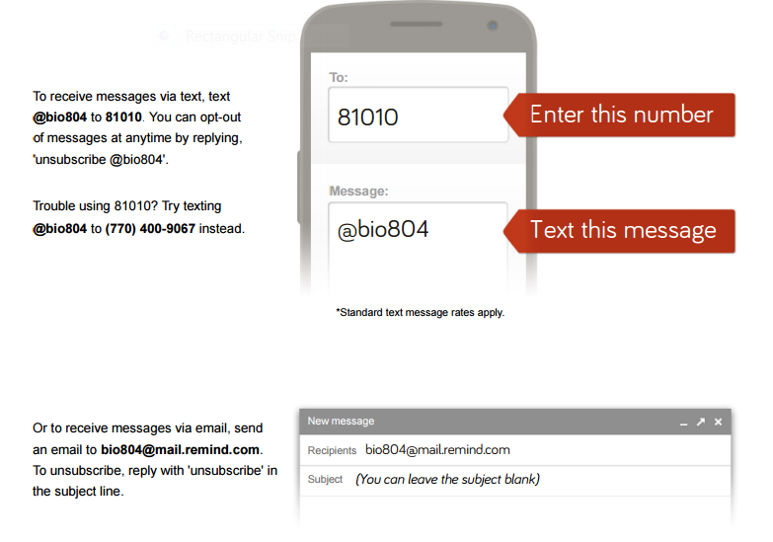
You will receive a message asking for your name. Please respond with your first and last name only (text messaging rates apply).

Technology in the Classroom

Some days in this course will be designated as BYOD (Bring Your Own Device) days. I encourage all students to bring their smart devices to Biology with the understanding that they are to be used only during the appropriate times. Smart phones, tablets, etc will be used in class for viewing notes, researching information, formative assessments, class reviews, etc. While such technology allows us to enrich lessons, any student without a smart device will still receive the same high quality instruction.

I will be “flipping” the classroom throughout this fall semester. This means I will be recording my lecture videos and your student will be watching them at home. By recording my lectures, students will have greater control over how they review. They can pause, take notes, or repeat/review any portion of the lecture at any time.

These lecture videos will be posted to the blog so it is imperative that both you and your student check this consistently throughout the semester. I post the week’s schedule every Monday and then edit it as things change throughout the week.
http://harrisonsouthcobbscience.weebly.com/

As always, I can be reached most easily via email. Please feel free to contact me at ANY time with whatever questions or concerns you may have.

Iesha.Harrison@cobbk12.org

Thursday, August 18 – Fall Semester Open House

SOUTH COBB HIGH SCHOOL SCIENCE DEPARTMENT FALL 2016
SYLLABUS ACKNOWLEDGEMENT

INSTRUCTORS: Iesha Harrison, Neshala Liggins………………………………….……COURSE: Biology

YOUR SIGNATURE BELOW INDICATES YOUR AGREEMENT WITH THE FOLLOWING:

- I have reviewed the class syllabus and understand the grading policy.
- I am willing to be contacted by email.
- I give my permission for my student to view G, PG, or PG-13 movies/readings if they are related to the curriculum.
- I give my permission for my student to participate in classroom pictures and/or videos and understand they may be posted to the class blog.
- I have access to the internet and will utilize the Synergy parent feature to check on my child's progress.
- My student has access to a computer and a printer and will be responsible for reading and printing required materials off the teacher blog. (Please see above for media center hours)
- I understand this course will implement the flipped classroom approach and will provide my student with a way to watch all lecture videos. (Please see above for media center hours)
- I have read and understand the academic integrity policy.

Student Name: ________________________________________ Class Period: _________
(Please print)

__________________________________________ _______________________________________
(Student's Signature) (Parent's Signature)

Parent Contact Information:

_________________________________________________________________________________________
(Parent Name(s) and Relationship(s) to Student)

__________________________________________ ____________________________________________
(Cell Phone Number) (Active Email)

Student Lab Safety Contract

I will:
1. Follow all instructions given by the teacher.
2. Read directions thoroughly before beginning a lab investigation.
3. Protect eyes, face, hands, and body while conducting a lab investigation.
4. Review all safety guidelines indicated in each lab before beginning.
5. Know the location of first aid and firefighting equipment.
6. Conduct myself in a responsible manner at all times in a lab situation.

I, __________________________________, (print name) have read and agree to abide by the safety regulations as set forth above and also any additional printed or verbal safety instructions provided by the teacher and/or district. I further agree to follow all other written/verbal instructions given in class. If I do not follow the safety instructions, I will be removed from the lab and receive a grade of zero on that lab. My parents will be contacted, and, depending on the severity of the infraction, an administrative referral may be written.

Student Signature: _____________________________________________________
Parent Signature: ______________________________________________________

RETURN THIS FORM WITH BOTH SIGNATURES SECTIONS SIGNED BY Friday, August 12, 2016.

